MS-ACCESS
- Open Microsoft Access and create a new blank database named "StudentRecords."

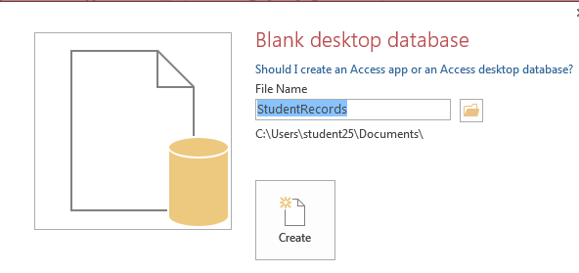

- Create a new table in the "StudentRecords" database with the following fields:

  - StudentID (Number),
  - FirstName (Short Text),
  - LastName (Short Text),
  - DateOfBirth (Date/Time),
  - Email (Short Text).
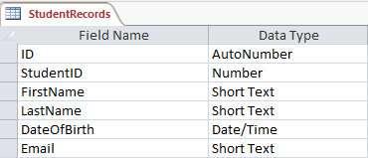

- Set the StudentID field as the Primary Key in the table.
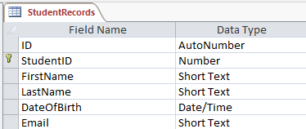

- Enter at least three student records into the table:
  - StudentID = 1, FirstName = John, LastName = Doe,
DateOfBirth = 01/01/2000, Email = john.doe@example.com

  - StudentID = 2, FirstName = Jane, LastName = Smith,
DateOfBirth = 02/02/2001,
Email = jane.smith@example.com

  - StudentID = 3, FirstName = Alice, LastName = Johnson,
DateOfBirth = 03/03/2002,
Email = alice.johnson@example.com

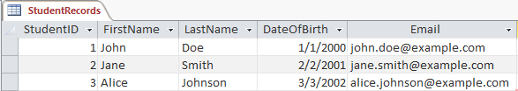

- Use a template to create a form named "StudentForm" for the "StudentRecords" table. Open the form in Layout View and add the existing fields (First Name, Last Name, Date of Birth, etc.) to the form layout.
Change the background color of fields, text color, and text size (12 pt).
Align the text in the fields as desired. Add a title "Student Records" at the top of the form.
Add navigation buttons to move between records and a "Save Record" button. Add a title “Student Record Form” and apply the necessary adjustments.
Save the changes and switch to Form View.

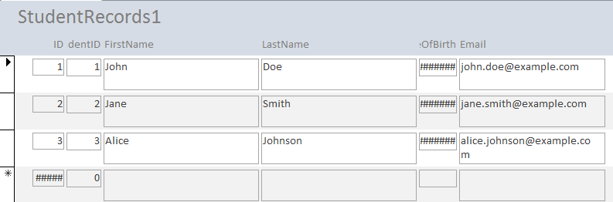
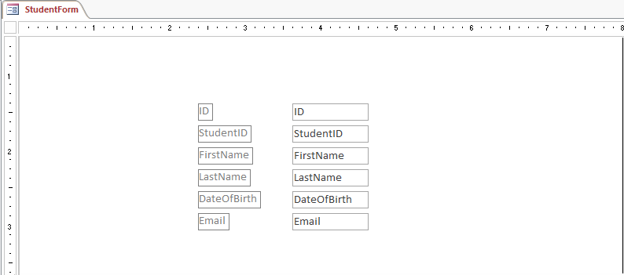

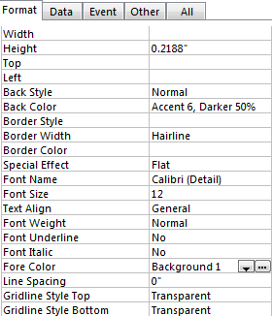

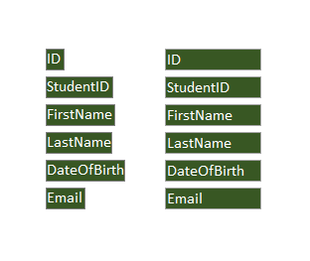

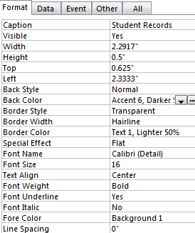

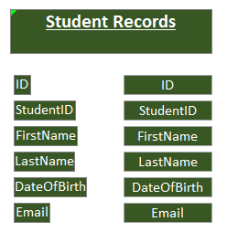

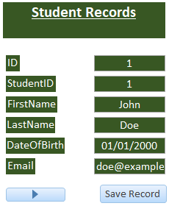
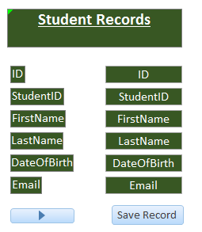

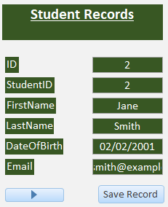
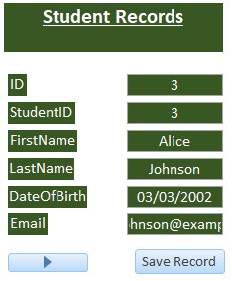

- Use the "StudentForm" to add a new student record:
  - StudentID = 4, FirstName = Mark, LastName = Brown,
DateOfBirth = 04/04/2003,
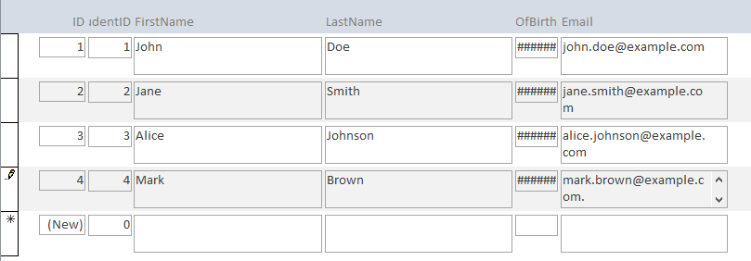
Email = mark.brown@example.com.

- Open Microsoft Access and create a new or open an existing database. Go to External Data > Import & Link > From Excel.
Import the "Students" and "Enrollments" tables from your Excel file. Go to the Database Tools tab and select Relationships.
Create a one-to-many relationship between the "Students" and "Enrollments" tables using the StudentID field.
Ensure that Referential Integrity is enforced.

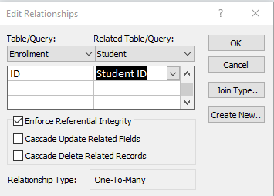

- Complete these tasks and ensure all steps are followed correctly to demonstrate your understanding of basic MS Access functionalities.

